**PROJECT**

**MEMBER’S NAMES AND ID’S:**

Yousef ElMenshawy 22-101241

Ali Wael 22-101000

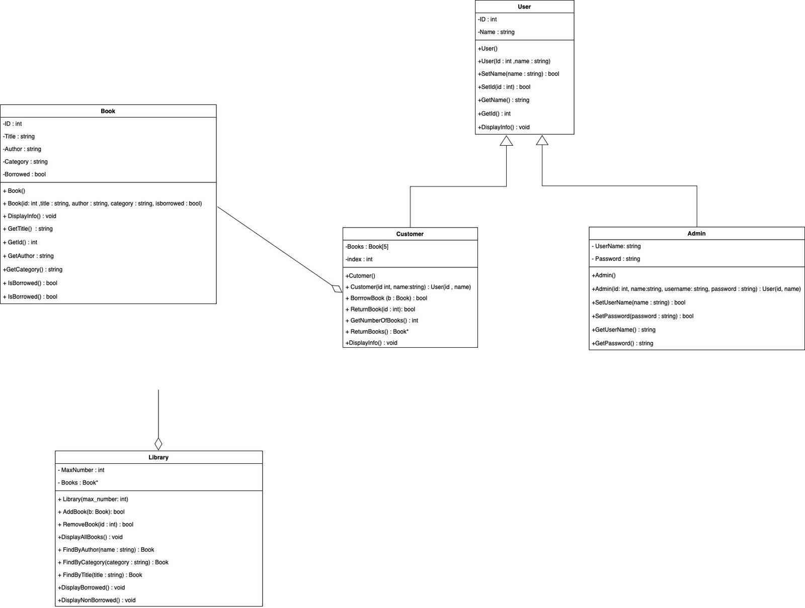

**Brief description for classes and its members:**

**User**: The `User` class is a basic class that represents a user in a system. It has a name and a unique identifier called `id`. It has three functions: `getName()` returns the name of the user, `getId()` returns the user's ID, and `printInfo()` prints the user's name and ID to the console. Other classes can inherit from this class and customize its functions.

**Customer:** The `Customer` class is a class that represents a customer in a library system. It inherits from the `User` class and has a name and an array of pointers to `Book` objects called `borrowedBooks`. It has four functions: `borrowBook()` to borrow a book, `returnBook()` to return a book, `getNumBorrowedBooks()` to get the number of currently borrowed books, and `getBorrowedBooks()` to get a pointer to the array of borrowed books. It also overrides the `printInfo()` function to print the customer's name, ID, and borrowed books.

**Admin:** The `Admin` class is a class that represents an administrator in a system. It inherits from the `User` class and has a name, username, and password. It has two functions: `getUsername()` to get the username of the admin and `getPassword()` to get the password of the admin. It also overrides the `printInfo()` function to print the admin's name, ID, username, and password. This class is a specialized class that adds functionality specific to administrators in a system.

**Book:** The `Book` class represents a book in a library system. It has a title, author, category, ID, and a flag indicating whether it is currently borrowed. It has six functions: `getTitle()`, `getAuthor()`, `getCategory()`, `getId()`, `isBorrowed()`, `borrow()`, and `returnBook()`. It also has a `printInfo()` function that prints the book's title, author, category, and ID. The class has an enumeration `BookCategory` that defines several book categories. This class provides basic functionality to manage a book in a library system.

**Library:** The `Library` class represents a library in a library system. It has a vector of pointers to `Book` objects and a maximum number of books that it can hold. It provides functions to add and remove books, display information about all the books, find books by author, category, or title, and display information about borrowed and non-borrowed books.